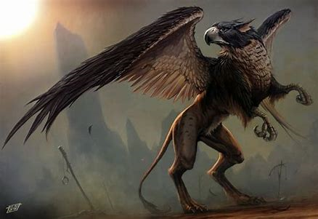 Griffin Newsletter - Terms 1 and 2
Welcome back! It has been wonderful to see all the children returning, ready to throw themselves back into school life. We have had a brilliant start to the term and it has been wonderful getting to know you all and your children. They have come back into school with enthusiastic and positive attitudes!
Here is a taste of what we will be learning over the next two terms:
In Maths, we will be learning about… | - Place value  - Addition and subtraction  - Multiplication  - Statistics  - Geometry
In English, we will be learning about… | - Narrative- story writing based on Gorilla by Anthony Browne  - Non-fiction- information texts  - Narrative -Myths (Norse Mythology)  - Poetry  - Non-fiction- instructions  - Narrative- story writing based on How To Be A Viking by Cressida Cowell
In Science, we will be learning about… | - Plants  - Animals including humans
In ICT, we will be learning about… | - Creating media-making music
In R.E. we will be learning about… | - What do different people believe about God?  - Understanding Christianity
In French we will be learning about… | - Greetings  - Je m’appelle  - Classroom instructions  - Colours  - Christmas vocabulary
Our topic is ‘Vikings- invaders or explorers?’ and we will be learning about… | - The links from the Anglo-Saxon and Viking times to today’s Britain and Bristol.  - Legacy-what did they leave behind?  - The invasion of Britain- why did they come? Where did they come from and where did they go?  - Settlements  - Everyday life  - Key/important/famous Anglo-Saxons and Vikings
Also… | PE will be taught on a Monday and a Thursday afternoon for terms 1 & 2. Please ensure that your child comes in to school on these days wearing their correct P.E. kit and that they are able to remove any jewellery that they have on (or provide tape for earrings for recently pierced ears). Some of these lessons will be led by the sports coaches, as they were last year. This term the children will be doing tag rugby, basket ball and gymnastics.  When the children have got a sports club after school, they need to come into school in their uniform and change into their kit after school before the club starts. If the club is on a Monday or Thursday, they will not need to change before the club starts, as they will already be in their kit.  Parent helpers: we are always very grateful for any help offered by parents able to come in to school on a regular basis to support with hearing readers, practising times tables etc. Please get in touch with us directly on email if you have any time to spare.  Sara.andersen@frenchayprimary.org.uk  Bethan.witherow@frenchayprimary.org.uk
Home Learning:
Area of learning | When and what will be sent home | When and what needs to be handed back in/how this will be checked
Spelling | Your child will receive regular spellings to practise at home. Please support your child with this. The spellings will be posted on Seesaw and a hard copy will also be handed out weekly. | Spellings will be regularly assessed in the spelling lessons.
Reading | This is an ongoing activity that we would anticipate children do 5 out of 7 days a week. This is both independent reading and reading aloud to an adult. | When your child reads independently, please encourage them to fill in a section in their reading record. When your child has read to you or another adult please write this in their reading journal. We would ask you to ask questions about the texts to help develop the children’s comprehension skills. We will be setting up a reading reward for the class later in the term.
English and CLJ | At the beginning of terms 1, 3 and 5, your child will be given an open ended project to complete based on their CLJ topic. Ideas for activities will be provided and this will be sent out next week. At the beginning of terms 2, 4 and 6, your child will be given an extended piece of writing to complete. This could be related either to the CLJ topic or the Literacy topic. | The class teacher will provide a date for the projects to be back in; this will be towards the end of a term.
Maths | Ongoing times tables and corresponding division facts to recall at speed.  Please support your child to practise their times tables on TT Rockstars a couple of times a week. The children will receive their usernames and passwords over the next couple of weeks and will have a go at accessing TT Rockstars at school, in order to then be able to log on at home.  By the end of year 2, children need to know 2, 5, 10x tables.  By the end of year 3, children need to know 2, 3, 4, 5, 8, 10x tables. | Times tables assessments to be completed in class.
Maths | Y1-3 – your child will bring home maths work related to what they are doing in class. Please support your child with this at home | This will be given out each Friday to be returned the following Friday and gone through in class.

