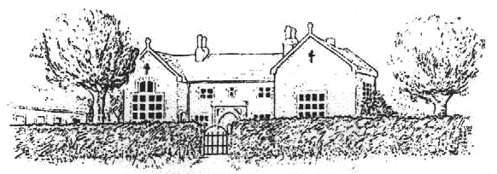
Frenchay C. of E. Primary School

CHURCHSIDE, FRENCHAY, SOUTH GLOUCESTERSHIRE, BS16 1NB
Telephone: 01454 868181, Fax: 01454 868182
Email: office@frenchayprimary.org.uk
Head Teacher Mrs Katherine Marks, BA (Hons) QTS, M.Ed. NPQH

School Opening September 2021

How parents can help

We are asking parents/carers to help keep our community safe by:

Sending your child to school with a coat and jumper (we will be increasing the ventilation at school and having regular fresh air breaks).

Ensuring your child washes their hands before and after school.

Only allowing your child to bring in essential items to school.

Keeping your child at home if they have a temperature, new cough or a loss of taste and smell and booking a PCR test.

Informing the school (by e-mail) of the results of any PCR tests.

Communicating with teachers via email where possible to reduce face to face contacts.

Collecting children promptly at the end of the day. This will now be at 3.30pm as prior to COVID.

Where possible drop your children off in the morning at the main school gates (please do not come into the playground). Gates open at 8.40am and close at 9am. Children can then enter their classroom on arrival where their teacher will be waiting.

Ensuring that gate entrances and pathways are clear for the community to enter and leave easily.

